https://lh5.googleusercontent.com/dplghwJq6X4fhzS5H6mFhAFj9x6vI-Y8xCT8NFOTS1m1Xqxiq7nkadVUnCPhdF0ePu4loIUkqVjtvmt0NXfO2k9ohAj4vSqxuecZS-EBDoWiRGD-hgPkQa4QEs6nQaUoqsWtkTeeVLr0namIZbmEyQhttps://lh3.googleusercontent.com/BTBdPiSJjxGslQH3BeZD4BaoJZ39HCgQmAhUsT_pMmuCBkQpXF4Oufxkc29xElrbY7UOC_t-XYD8wCe8-xr0WMFCu3DhySoqaYXxkDd4zDvRd6uFglNfbvwNH7fYiWW7sNqHblYmu1wrAZV9wwFdXA

**GHARDA FOUNDATION**

**GHARDA INSTITUTE OF TECHNOLOGY, LAVEL**

Department of Computer Engineering

**Evaluation Sheet**

Class: TE-Computer Engineering Sem: V Subject: **Cloud Computing Lab**

Experiment No: 3

Title of Experiment: Virtualization. Objective: study bare metal hypervisors.

Name of Student: Niraj Nitin Surve Roll No: 68

Date of Performance:

|  |  |  |  |
| --- | --- | --- | --- |
| Sr. No. | Evaluation Criteria | Max Marks | Marks Obtained |
| 1 | Practical Performance | 8 |  |
| 2 | Oral | 5 |  |
| 3 | Timely Submission | 2 |  |
|  | Total | 15 |  |

                   Signature of Subject Teacher

     (Mr. S. S. Tathare)

**Screenshots –**

**Step 1: Install Xen Server**

Niraj Nitin Surve

1. **Insert Bootable Xen Server CD into CDROM and Make first boot device as a CDROM from BIOS**

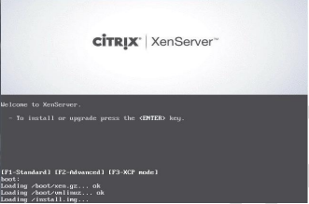

1. **Press F2 to see the advanced options, otherwise press Enter to start installation**

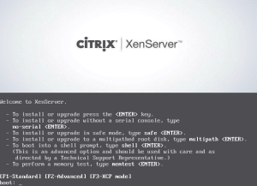

1. **Select Keyboard Layout**

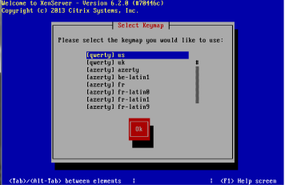

1. **Press Enter to load Device Drivers**

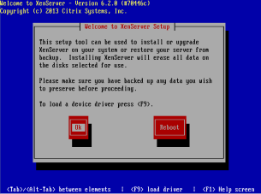

1. **Press Enter to Accept End user license Agreement**

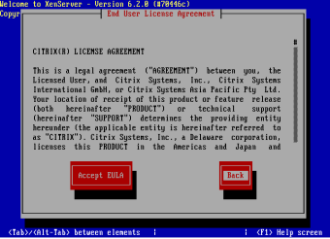

1. **Select Appropriate disk on which you want to install Xen server**

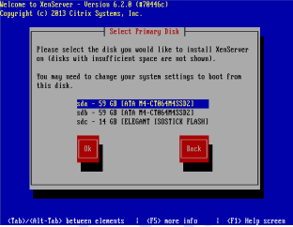

1. **Select Appropriate installation Media**

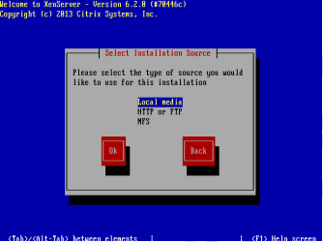

1. **Select Additional Packages for installation**

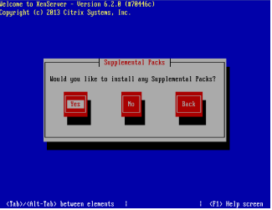

1. **Specify Root password**

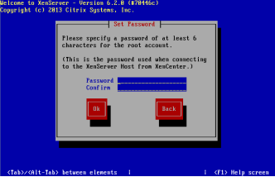

1. **Specify IP Address to a Xen Server**

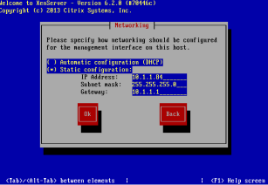

1. **Select Time Zone**

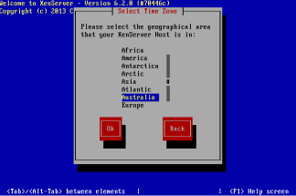

1. **Specify NTP Servers address or use manual**

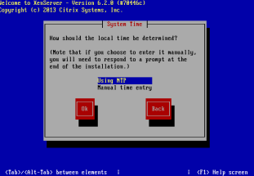

Once installation is done you will see the final screen shown below.

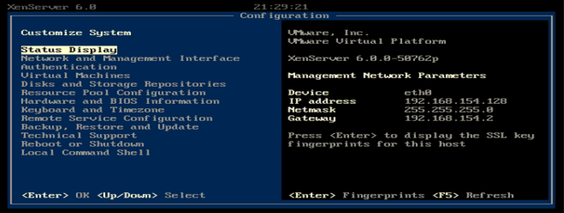

**Step 2:Connect Xen Server to Xen Center**

To connect to the XenServer host you configured earlier, click Add a server.

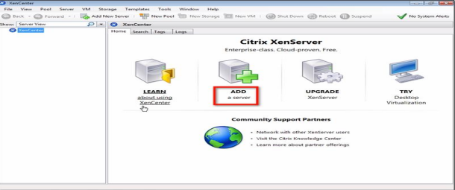

Enter the IP address. Also enter the password assigned for root account. Click Add.

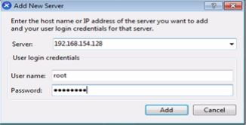

Adding a new XenServer to XenCenter is to save and restore the server connection state on startup. Check the box.

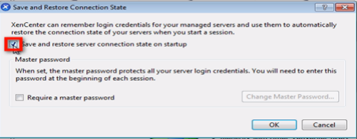

Click the Require a master password checkbox, and then enter desired master password in the fields provided.

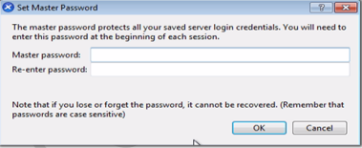

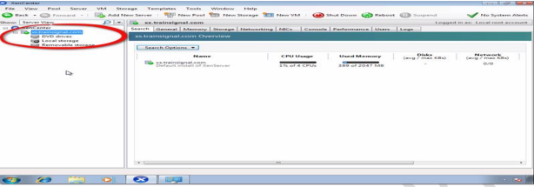

**Step-:3 Create Storage Repository and Installing VM**

Install Operating system on Xen Server. Right click on Xenserver icon on xen center and click on New SR.

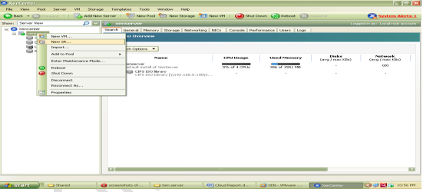

Now Select Windows CIFS library

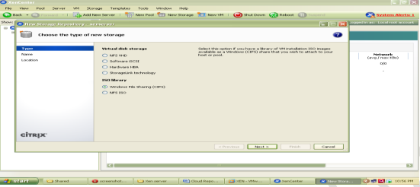

Specify Storage Repository Name

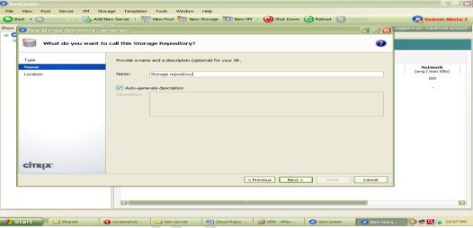

Now specify path of shared folder at client side which holds all iso files of os or VM

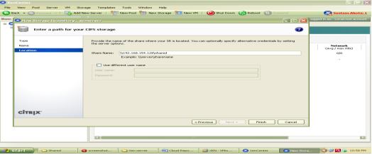

At the end Click on finish to create SR.

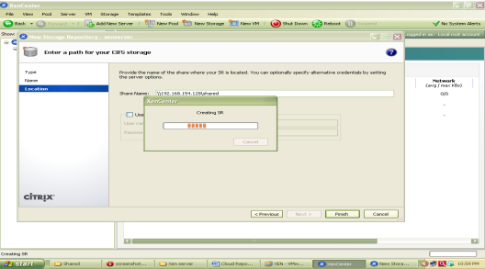

To check all iso files click on CIFS library and select storage this will show you all iso files.

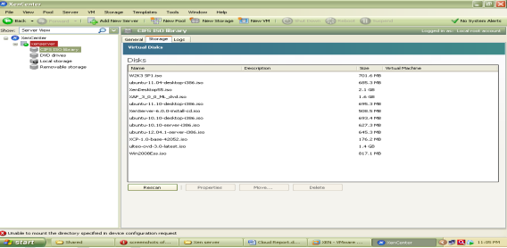

Installation of UBUNTU Server on Xen Server

Step 1 -: Right click on Xenserver icon on xen center and select New VM

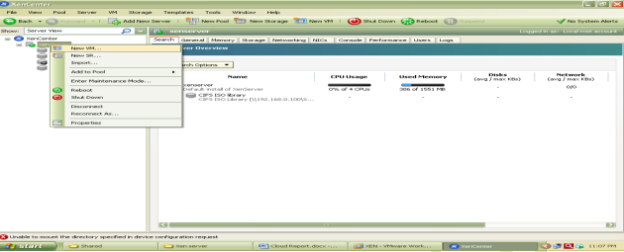

Now select an Operating System to be install here select Ubuntu Lucid Lynx and click on next

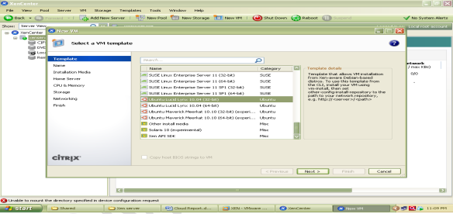

Now specify Instance Name as ubuntu server

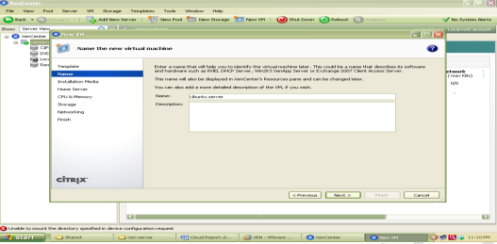

Select iso file of Ubuntu server 10.10 to be install

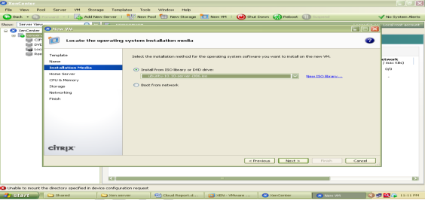

Now select hardware for vm i.e. no. of cpu’s and memory

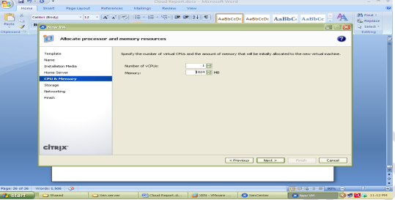

Select local storage

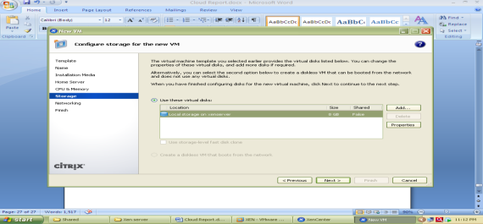

Select network

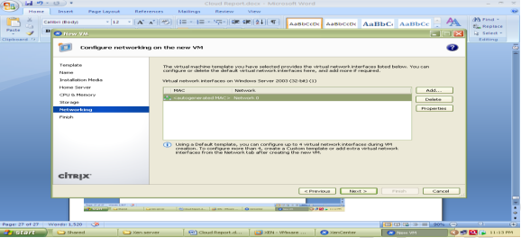

And click on finish

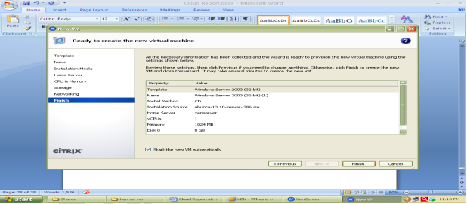

Now go to Console tab to install ubuntu and follow installation Steps.

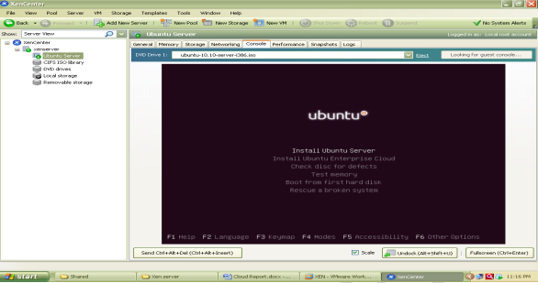

The Xen orchestra provides web based functionality of Xen Center.it provides access to all the VMs with their lifecycle management which are installed over Xen Server.

